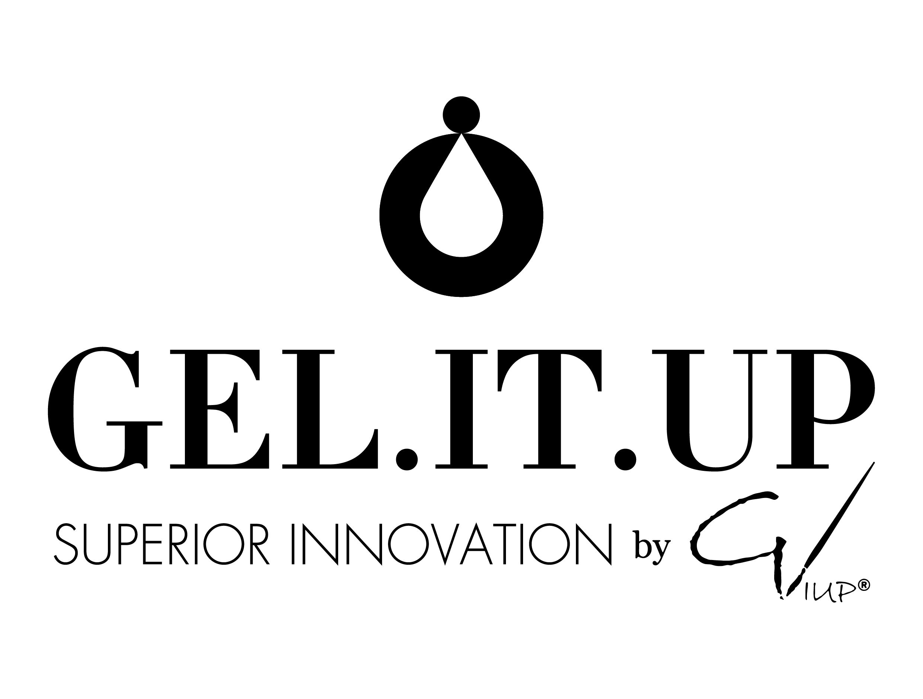
8 Racho Dimchev, Sofia, Bulgaria, 2700 · VAT BG202102027
info@gelitup.com · gelitup.com

Welcome to the family!
Dear [name],
Welcome to the GEL.IT.UP Ambassador family! We're so excited to have you on board, and even more excited for you to open your first box.
Before you dive in, here's how to make the most of your unboxing:
1. Film before you open it. Start recording before you cut the tape — the reveal is the best part, and your followers will want to see it too.
2. Show every piece. Take a moment to show off each shade and product clearly — good lighting near a window works best.
3. Share your first impressions. Tell your audience what you're most excited to try first.
4. Use your code [discount code]. Your personal discount code is included in this box — share it with your followers for 20% off. Please note that the discount code is only valid for www.gelitup.com and not to be shared publicly but on private messages to your subscribers / followers
5. Post it. Share your unboxing on Instagram or TikTok.
DON'T FORGET
• Tag us @gelitupinternational and use the hashtag #GELITUP so we can find and feature your post.
• Send your content and your social media handles / tags to our WhatsApp / Viber at +30 694 071 5234 as well — this way we can share it directly and make sure you're tagged.

As a reminder, here's what you get as a GEL.IT.UP Ambassador:
• Free product drops, sent before anyone else
• Your own personal discount code, plus 20% off to share with your followers
• Your posts featured to thousands on @gelitupinternational #gelitup and other country social media platforms!
Please remember that you are representing a company who is mutually supporting you and we appreciate professional content. If you have any questions at all, just reply to this email or message us directly — we're always here to help.
Welcome to the family,[name]. We can't wait to see what you create.
With love,
The GEL.IT.UP Team

